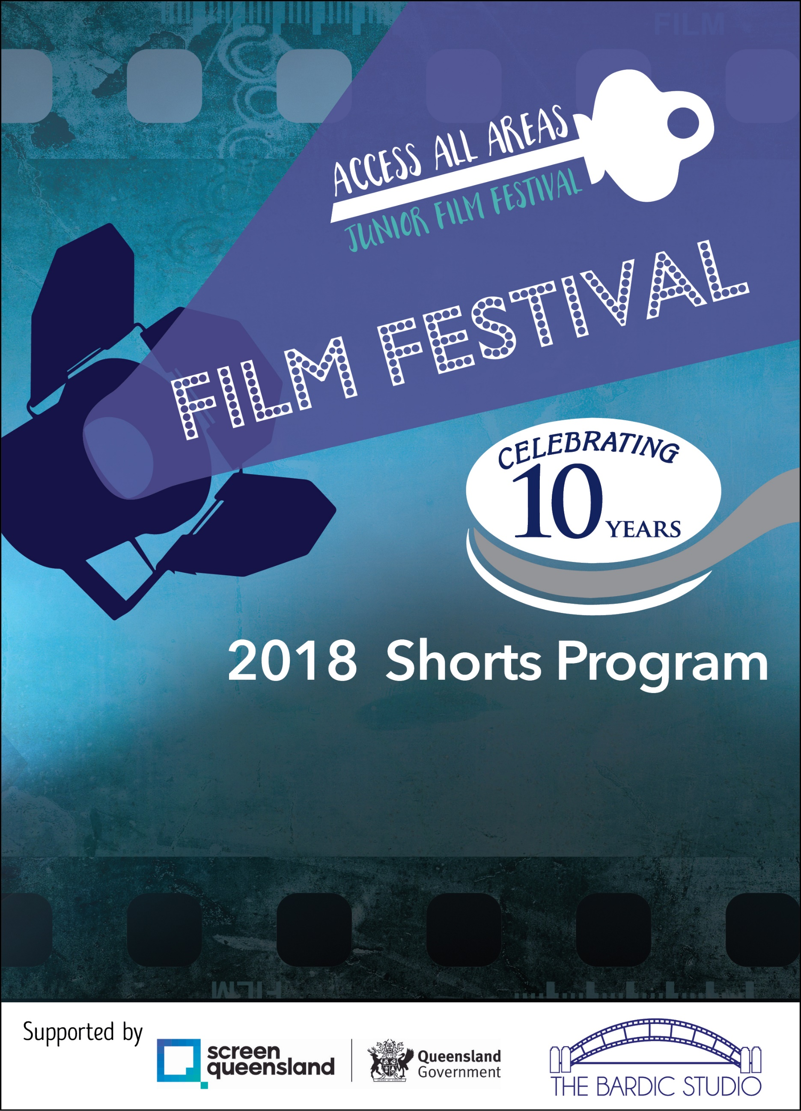

**Hosted by MyHorizon and Redland City Council**

Thursday 26th April 2018, 4:30pm – 5:30pm

Open Captions, Sensory Screening and Chillout Area

Myhorizon, 1-15A Runnymede Rd, Capalaba

Tickets are FREE however bookings essential: Call 3824 7007 or register via www.all-access-film-children.eventbrite.com.au

Flashing light free. Wheel chair access & accessible toilets. Film suitable for 5-12 years however all are welcome. For our social story or more info, email [events@myhorizon.org.au](mailto:events@myhorizon.org.au) Children must be supervised by a parent or carer at all times.