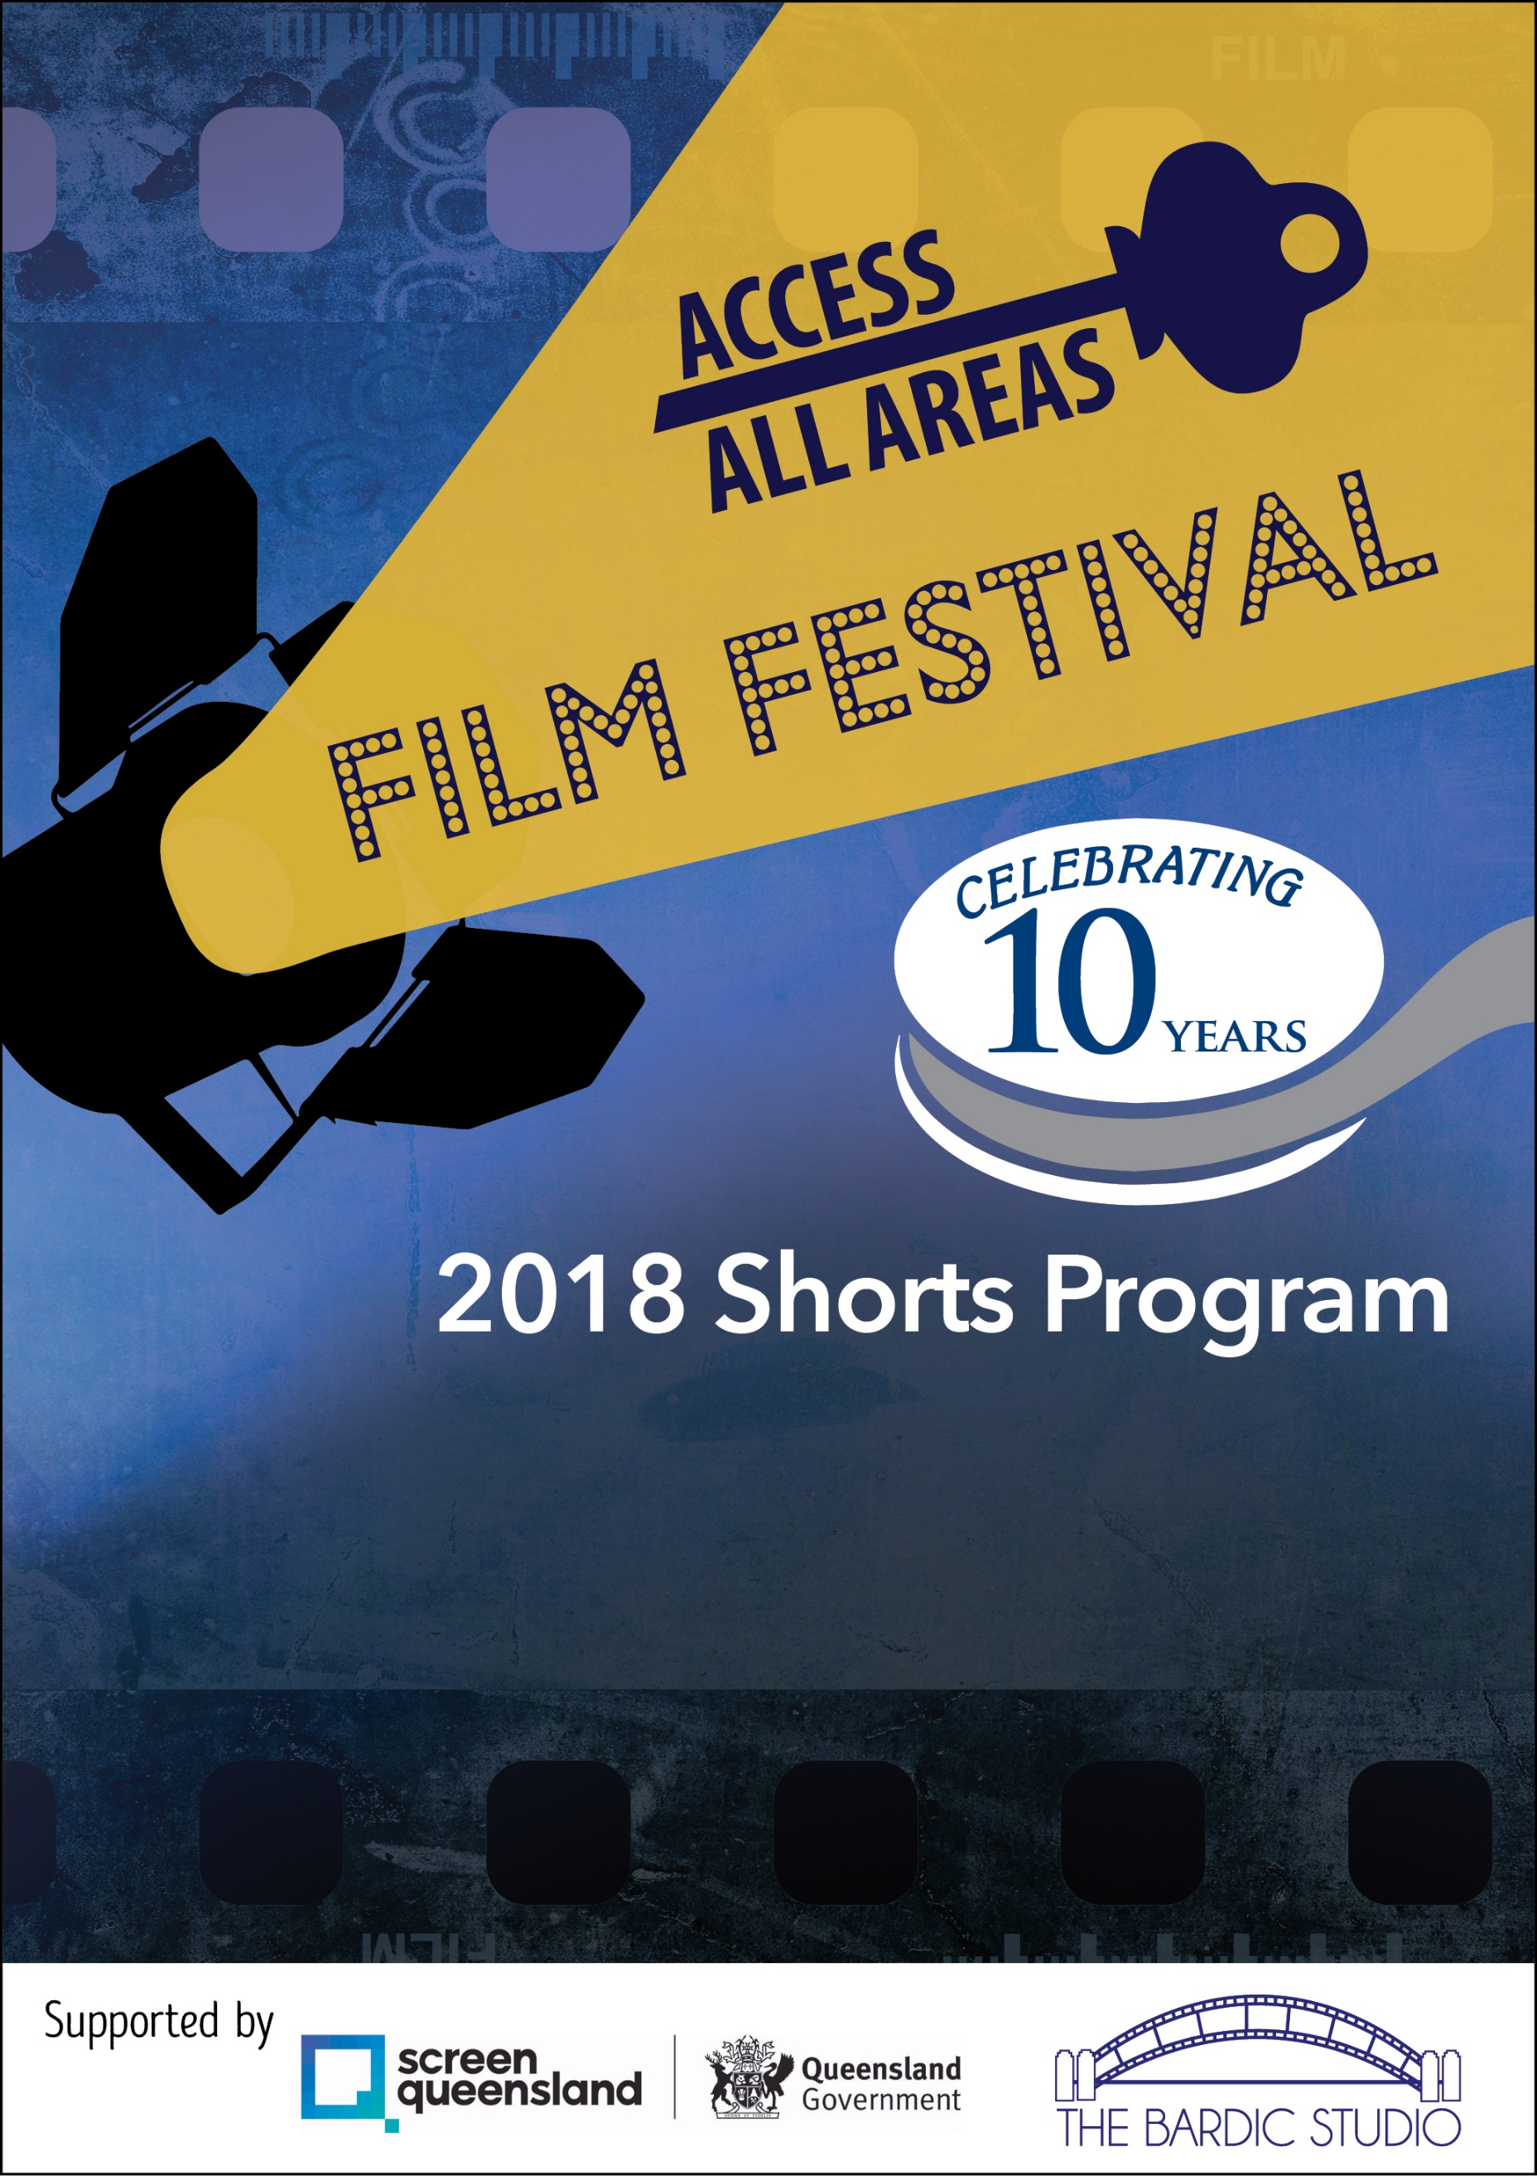

**Hosted by MyHorizon and Redland City Council**

Thursday 26th April 2018

6:00pm – 7:00pm - Room 1: Open captions

6:00 – 7:00pm - Room 2: Audio description

Myhorizon, 1-15A Runnymede Rd, Capalaba

Tickets are FREE however bookings essential: Call 3824 7007 or

register via [www.all-access-film.eventbrite.com.au](http://www.all-access-film.eventbrite.com.au)

Flashing light free. Wheel chair access & accessible toilets. Films suitable for 12+ years however all are welcome. For more information, email events@myhorizon.org.au . Please note that children must be supervised by a parent or carer at all times.

­